**AS5102 STANDARD and STELTH PUMPS by Terry Day, New Fluid Technology**

**This report analyses two subjects; 1; the problems with standard AS5102 and 2; a description of the Stelth pumping concept as it pertains to energy efficiency.**

**CONCLUSIONS:**

1. A conventional pump awarded “8.1” “Stars” according to AS5102 testing, when placed above the water instead of significantly below it, cannot attain the minimum 120 litres per watt hour at 2.6 metres of head at the same RPM.
   1. When placed above the water level it must increase RPM to reach the AS5102 minimum flow rate of 120 litres per minute, thus increasing amps drawn.
2. That changes the litres per watt hour.
   1. Put another way; A pump tested 48 inches below the test tank water level to AS5102 standard, would have to be placed in an equivalent 48 inch, plus, deep pit next to the pool to achieve the same litres per watt hour.
3. AS5102 does not stipulate a test tank water level and does not allow a height offset, therefore the results from different test stands, each of which comply with AS5102, will give different litres per watt hour and may indicate different “Stars” depending on the guessed water level. The Bernoulli Equation does not address or adjust the test results.
   1. Therefore AS5102 is flawed.

**RESULTS:**

When realistically placed above the water level, just a minority of conventional pumps can achieve 42.915 “litres per watt hour” to qualify for low 8 SRI whereas the Stelth pump achieves above 53.644 litres per watt hour (equivalent to 9 SRI).

**TESTING, ANALYSIS AND RATIONALE**

The AS5102 test stand scheme is adequate to test any pump. That is not the problem.

The problem is that AS5102 does not allow for the “reality” testing for “litres per watt/hour” for any pump because the testing is subject to particular directives found in AS5102 while AS5102 is otherwise not definitive in other important areas such as test tank water height.

Therefore AS5102 gives only highly interpretable instructions on the test method.

Different test stand interpretations, especially of water level and practical testing yield very different “litres per watt hour”, for the same pump. Different test stands yield different results for the same pump. Therefore AS5102 is not definitive standard

**PREAMBLE**

For Australia, the objective is to have a pump attain as high “litres per watt hour” as possible so that Australia’s Dept of Climate Change will assign it a high energy Star rating.

In other countries such as the U.S.A, “energy efficiency”, meaning high “litres per watt hour”, is, or should be, the goal regardless of the introduction, or not, of a Star rating system.

The Australian Star rating system flaws are demonstrated by the following experiences.

Recently in the AS5102 compliant test stand at University of Sunshine Coast (USC) the Stelth pump was given, in one test, 7.2 stars (34 litres watt hour) and in another test 7.8 stars (38.225 litres per watt hour). (USC initiated the decimal point in the results so we have adopted it as practical).

**Fig 1** is a printout from Waterco who tested the Stelth pump at 8 + stars on 14/11/2011. However we have increased the Stelth performance since then.

The results from USC are;

1. Stelth 35 litres per watt hour; 7.2 Stars from test 1
2. Stelth 38.225 litres per watt hour; 7.8 Stars from test 2
3. The Zodiac pump with Fasco 1 hp iMPower motor; 8.1 Stars

And otherwise

* Stelth pump tested by Waterco in Nov 2011, 45.62 litres watt hour; 8.2 Stars….see **Fig 1**.

These serious anomalies require some attention as they were all derived via AS5102 compliant test stands. The above results from each would be accepted by the Dept of Climate Change.

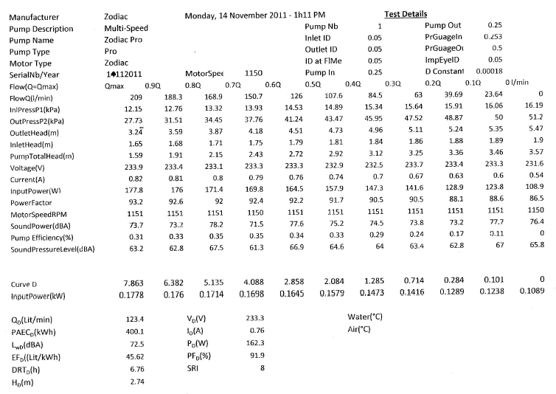

**Fig 1** Waterco results for Stelth pump Nov 2011, 45.62 litres per watt hour- 8 + stars

**ANALYSIS**

AS5102 requires a pump to be tested at a flow of at least 120 litres/minute at 2.6 metres of head (2.6 metres = 25.5 kPa) being the minimum allowable flow point that falls right on the D curve. 120 litres per minute has to be at 2.6 metres of head or it would not be on the D curve.

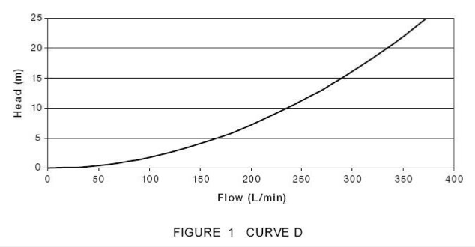

**Fig 2** “D” curve from AS 5102

The 120 litres per minute at 2.6 metres of total head is the lowest allowable and it also delivers the highest litres per watt hour for any pump because the low water speed has reduced the system resistance.

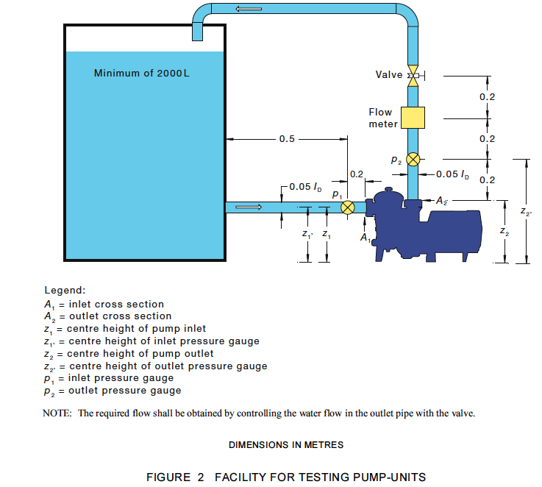

**Fig 3** the USC test stand is built according to the AS5102 scheme above as is also the (hidden behind a wall) Waterco test stand

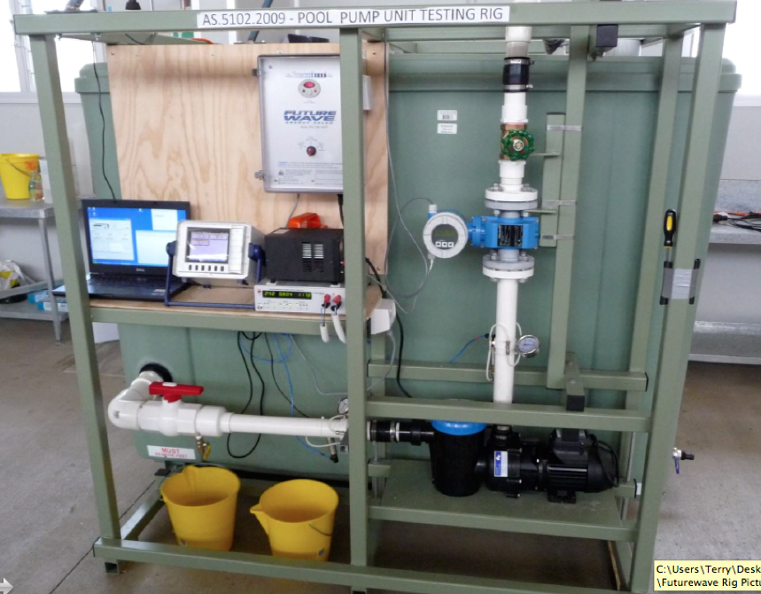

**Fig 4** the USC test stand built to AS5102. Water level is almost to the top of the tank

The USC test stand, built according to AS5102, has a tank water level 1.225 metres (48 inches) above the pump centre line and that exerts a head pressure of 12 kPa at the pump inlet.

Accepted pump testing standards require offsetting (cancelling) this non-real inlet head. AS5102 does not.

That means that a pump that achieves 44 litres per watt hour and is awarded 8.1 Stars according to AS5102, when realistically placed at an average height above the water level, will really run with the 12 kPa positive pressure removed.

Equally important, because that pump is now above the water and not under it, there is a suction (negative) pressure at the inlet of 9 to 10 kPa depending on the pump’s height above the water, the pipe length, the number of elbows etc. (see **Fig 12** and **Fig 15**).

That pump cannot then attain 120 litres per minute because it has lost the 48 inches of water height above it and, in addition, the flow rate is further retarded by the 9 – 10 kPa suction at its inlet.

* So the reality is that, if tested in its place, the litres per watt hour for a conventional centrifugal pump are never the same as those obtained by testing according to AS5102.

2.6 metres = 25.5 kPa. So now that same, in-place pump, has a discharge head of only 15.5 kPa; instead of what is assumed and believed.

However what is calculated and also confirmed by actual tests, is that because that pumps flow is significantly reduced when it is put above the water, the RPM must be increased to restore the flow back up to 120 litres/minute on the D curve, which also lifts the pressure back to 2.6 metres total head across the pump.

That significantly increases the amps drawn by the motor and consequently the “litres per watt hour” are, in reality, significantly different than if testing per AS5102. (See the Bernoulli Equation discussed below).

If it is believed that 2.6 metres (25.5kPa) discharge pressure is needed to push the water through the system and filter, the reality is that that may not be achieved when an 8 + star pump according to AS5102, is placed a practical distance from the water at a realistic height above it.

The significant question then is: is the actually measured 15.5 kPa discharge pressure enough to work the system and filter?

Answer: It had better be because that is what you really get when you put an 8.1 Star pump, tested to AS5102, in a real situation above the water level instead of below it.

* Further; if it is insisted that 2.6 metres (25.5kPa) of discharge head is necessary to work the filter and system then you would literally have 25.5 kPa discharge plus 9+ kPa suction = total head of 34.5 + kPa across the pump.

You then have 34.5kPa (3.519 metres) which lands on the D curve at about 150 litres/minute. No pump can achieve even close to 8 stars at that point on the D curve.

**SINGLE STARS**

Yet another problem is encountered with the awarding of single stars as per AS5102:

**Fig 5** below gives the litres per watt hour against the corresponding star.

If pump A, according to AS5102, achieves 34.5 litres per watt hour (7 stars) and pump B achieves 44 litres per watt hour (8 stars), if each, either by being tested with different, guessed, tank water levels, allowable under AS5102, or Variable Speed Drives with coarse RPM increments of 50 RPM instead of 10 RPM, suffer a reduction of a mere 1% in litres per watt hour, then the 8 star pump remains 8 stars but the 7 star pump is now a 6 star pump (divide 34.5 and 44 respectively by 1.01 and check the results against the chart of **Fig 5**).

Guessing where to place the test tank water level during testing could give this unfortunate result if you are not allowed a height offset.

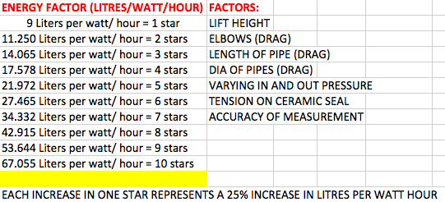

**Fig 5** Litres per watt hour and corresponding “Stars”

This is not pedantic because it really could and may even have happened.

Merely different water levels could do this. Also at very low RPM, 50 RPM increments are too coarse and result in much greater variation than 1%.

Because each exact Star increase is 25% more litres per watt hour, the difference between 34.5 and 44 is 27.53%. But pump manufacturers know that some of their customers know that the difference between two exact stars is 56%.

If it is claimed that a close result would be warrant a favourable “benefit of the doubt” then you introduce the idea of an arbiter.

In a situation where “Stars”, at present, in Australia, are self-assessable, who would be the arbiter? : the pool pump manufacturer out of commercial desperation or the Department of Climate Change?

The belief that AS5102 provides a baseline for fair comparison of pool pumps is an incorrect one.

**THE MAIN ISSUES**

The chart of **Fig 5** is definitive and proscriptive but the tank water level of **Fig 3** is not defined.

The directive in AS5102 is to control the flow with only the one valve on the discharge pipe.

Quoting the Bernoulli Equation does not simply “fix” the testing questions. The Bernoulli Equation does correctly say that any pressure change of the flow across a pump gives the true indication of the pump performance. The Bernoulli equation merely mathematically formalizes the obvious.

I.E, It does not matter what the pressure either side of the pump is. The two pressures only have to add together to get the desired pressure change (at least 2.6 metres at 120 lit/min in the case of AS5102). The Bernoulli Equation predicts that it does not matter if most of the total pressure is found at the discharge or the suction side of the pump and it does not matter if there is negative (suction) pressure or positive pressure at the inlet to the pump. Both added together at a chosen flow rate convey the real performance of the wet end of the pump.

* But worth noting first; to derive the true efficiency of the pump + test stand as a unit, the watts of water power must be divided by the motor shaft watts and not the electrical watts. You cannot test the efficiency of any pump; you can only test the efficiency of a pump and test stand system using shaft watts and not electrical watts. Keeping that in mind;

Quoting the Bernoulli Equation to justify the AS5102 testing hides the real problem. That is that the pump flow drops when placed above the water and consequentially its RPM and amps have to be increased.

* When you alter the motor speed its efficiency and torque changes. It is not running at the same RPM when the pump was previously tested according to AS5102. The difference is not much but at those low speeds and if the litres per watt hour are close to the changeover point for a higher or lower SRI, it can result in a different SRI than it previously was awarded when tested to AS5102 below the water level without a water height offset.
* Also the wet end component of all pumps gives different efficiencies at different speeds. Generally the lower the speed, the lower the efficiency. Conventional centrifugal wet ends are not very efficient at very low RPM.

For that last reason, AS5102 is formulated to assess litres per watt hour and award energy stars for a make believe situation no pump ever encounters and which subsequently changes when the pump is bolted in place above the water. (after being purchased based on unreality testing results…. You pay for A but get B!).

With the necessary RPM and amps increase the Bernoulli Equation is not negated or ignored. The pump has simply shifted the 25.5kPa pressure difference upwards. The same 25.5kPa still separates each side of the pump but the numbers differ just like 10 and 35.5 and also 100 and 125.5 are both 25.5 difference.

**AS5102 ARTIFICIALLY FAVOURS CONVENTIONAL CENTRIFUGALS**

It is in the interest of manufacturers of the best performing centrifugal pumps to leave AS5102 as it is. This is because those pumps cannot perform well at very low RPM due to the fact that then the kinetic energy in the water flinging directly off the impeller is not enough to enable the diffusers to operate efficiently and in addition the diffusers partially block the flow.

The Stelth pump can achieve the 120 litres per watt hour at 25.5 kPa total head at lower RPM than conventional centrifugal pumps. This is because the Stelth has no diffusers but instead generates its pressure by centrifugal action in the vortex.

Important to note; reduced RPM reduces amps draw at least as effectively as any other maneuver, including impeller design, diameter or diffuser or pump geometry. Therefore any pump with low RPM will likely have high litres per watt hours including at the required point on the D curve.

A situation could happen where pumps 27% apart in litres per watt hour are assumed by a customer to be 56% apart.

A pump could be purchased because of its SRI or litres/watt hour and this could give rise to complaints or challenges to AS5102 by disgruntled pump manufacturers or informed customers.

AS5102 is flawed because it does not define a test tank water level thus leaving that to a guess. It then does not allow that guessed water height to be offset to simulate a real situation of pump above and not below the water level, Therefore it is not an adequate standard.

**THE OPTIONS FOR INTERESTED PARTIES**

**Option 1:** Challenge the Department of Climate Change regarding AS5102.

**Option 2:** Work quietly to get a full understanding of the real situation to be ready for any outcome.

If manufacturers with low pump AS5102 derived SRI fully understand the issues described herein, and most do not yet, it might be in their interest to challenge AS5102 just to get a time buying, start again, situation.

If the Dept of Climate Change is unresponsive, finding a loophole in AS5102 might work. The water tank must hold minimum 2,000 litres. If the water level is down at pump inlet height and the tank broader as it is in **Fig 17** and **Fig 18,** would it deviate from AS5102?

* Paradoxically, a squat tank is necessary if turbine type flow meters are employed (allowed in AS5102) due to the manufacturers stipulated pipe length each side of the water turbine and this makes it impractical to discharge vertically as in the AS5102 test stand diagram. (compare **Fig 3, Fig 16** and **Fig 18**). This is confusing and subject to interpretation.

If the water level were below the pump it may or may not be argued against. But this would be another case requiring arbitration. If you need arbitration then you obviously are not dealing with a true standard.

Putting a restriction in the inlet pipe, before the pressure measurement, that causes suction at the pump inlet of 9 to 10 kPa may not be noticed. It is not prohibited in AS5102 because it is not addressed. But if anyone knew, it could be criticized and others could also demand to do the same thereby leveling the field somewhat. If already awarded a particular SRI they may find it is then different.

**Option 3:** Diplomatically advise the Department of Climate Change of the problems with and through a well known authority on pumping issues.

This could be done via a friendly private chat with the Department.

**Option 4:** If the Department of Climate Change is unresponsive, notify the media.

* The above ruminations about arguments and loopholes demonstrate the difficulties and ambiguities associated with AS5102.

For the Department to reject these requests would demand some challengeable reasons. They would know that.

It is obvious that if the various states in the USA, Europe or anywhere wish to introduce “energy efficiency” legislation that Australia’s attempt is instructive. The dissection of AS5102 has revealed a better way.

**HOW AS5102 COULD BE RETAINED AND AMENDED SUCCESSFULLY**

1: Direct that any chosen water level height pressure in the test tank be cancelled in the calculations and in addition that a non-negotiable average suction pressure of say 9.5kPa be applied at the test stand as part of the total pressure across the pump. In addition;

* Either get rid of the “Stars” altogether or make them jump in ¼’s (untidy).
* Get rid of the “Stars” and only put the yearly “litres per kilowatt hour” on the pump label.
* Or put a simple curved bar with a color difference that reaches marks of much finer increments on the bar. Say 100 increments. The marks at each 10 could be more pronounced. That would convey an energy efficiency %.

**THE STELTH INITIATIVE (for information only)**

The Stelth pump idea enables a breakthrough in energy reduction for pool filtration (and for other pumping categories).

It (only partly) does so by enabling lower RPM, thereby reducing amps.

It also performs well at high RPM.

Performing well at both high and very low RPM is a challenge for any pump. So it is for the Stelth.

The job is not made easy by underpowered motors (such as the Fasco axial flux motor). If that motor were 1.5 hp the job would be easy.

Higher HP motors can swing a larger diameter impeller at lower RPM getting the amps down. They also enable big and small pump performance while also enabling higher litres per watt hour at low RPM.

**STELTH AND A 1.5 HP MOTOR**

Our extensive testing has shown the Fasco 1 hp iMPower motor to be very efficient. (see POWER FACTOR below)

**Fig 13** and**14** shows several things:

Even when the RPM of the Stelth, with the Zodiac E Pump motor, is reduced significantly (via the software and not the load) the pressure curve and efficiency curve are still higher and wider than the Zodiac 1 hp pump with Fasco motor.

If the motor driving the Stelth were a Fasco iMPower of 1.5 hp instead of 1 hp, which is more efficient than, for example, the Zodiac E Pump and similar type motors, we predict the wire to water efficiency will go to 50% or higher. (at present 2 to 3 hp driven Stelth pumps without leaf bowls reach around 60% wire to water efficiency).

It would enable the Stelth to deliver above 53.644 litres per watt hour (9 stars in Australia) in any size, but at higher RPM, behave well varying from equivalent to 1hp to 2 + hp pumps.

It already does so with the 1 hp Fasco iMPower motor. The litres per watt hour would be highest for all countries, Energy Stars or not.

Our rule of thumb is that you want 220 lit/min at 150kPa to 330 lit/min at 100kPa from much larger pumps at full speed (2hp +).

Thus the Stelth is as efficient as the Zodiac at 330 lit/min using the less efficient Zodiac E Pump motor. With a more efficient upgraded Fasco 1.5 hp motor, the efficiency would be much higher between 220 to 330 lit/min. But when both pumps are run at low RPM above the pool the Stelth with Fasco 1 hp iMPower motor delivers above 53.644 litres/watt hour (equivalent to 9 stars) but the Zodiac pump (just an example) still delivers litres per watt hour to keep it at 8 stars.

We do not want to state the exact litres per watt hour because all pumps will differ a little in efficiency of both their motors and wet ends.

**Fig 14** shows the Stelth performance at 2600 RPM employing the affinity laws which predict reasonable accurately that the flow reduces as the RPM, the pressure reduces by the square and the amps reduce by the cube.

In summary, the Stelth with a 1.5 hp Fasco motor would outperform all pool pumps at high and low speed including delivering the highest litres per watt hour of any pump.

This is based on that the Stelth already delivers more than 53.644 litres per watt hour using the Fasco iMPower 1 hp motor at about **1050 RPM**.

The Zodiac delivers Litres per watt hour qualifying for an SRI of 8 at **1350 RPM**.

We are not picking on Zodiac. On the contrary, it is one of the best pool pumps. But we have to compare against some high performance standard in the event we are challenged to demonstrate our case.

These results we quote here are from actual testing of the Stelth pump and the Zodiac with the 1 hp Fasco iMPower motor.

We have also tested under identical conditions, the Pentair Intelliflo, the Davey with the 1 hp Fasco iMPower motor and the Waterco with the1 hp Fasco iMPower motor. We have tested most pumps sold in Australia and some from the USA.

We have tested them all in the same test rig in the way this report recommends; IE we impose a suction on the inlet to provide approx. 9.5 kPa and on the discharge side we impose approx 16kPa. = 25.5 kPa total head across the pump.

We believe the 16kPa is adequate to work the filter and system because of the slow water speed which reduces the system resistance. The daily run time (DRT) is 6.9445 hours or for two daily turnovers is 13.889 hours.

The Stelth pump is under half the noise (SPL) of any other centrifugal pump.

The Stelth wet end from which **Fig 13** and **Fig 14** data is obtained is physically much smaller than any centrifugal pump.

Our next steps are to obtain the new Fasco iMPower 1.5 hp motor from the USA and other high efficiency motors from Australia.

**POINT OF THIS REPORT**

The main purpose of this report is to point out the anomalies in AS5102.

Otherwise we are not asking the Department of Climate Change to do anything but note the situation with the Stelth development and to be aware that the Stelth pump has the potential to lift the energy efficiency of the pool industry and also of a number of other important pumping applications.

We invite dialogue with the department on a friendly cooperative basis

**GRAVITY; OUR OBSERVATIONS**

After the water is pumped to the highest point in the system, gravity pulls it back to the pool water level. We were running our return pipe down to water level but we realized that that was too unsure. Different pumps will have different size and types of filters and different numbers of elbows, pipe lengths etc and it would be impossible to calculate an average benefit due to gravity. We have abandoned that and rather we discharge the return water from all pumps tested from a height that cancels any effect of gravity on the system. But our tests showed that gravity working beyond the systems highest point, assists all pumps to deliver slightly better litres per watt hour. But it is too indefinable to stipulate in a Standard.

**POWER FACTOR; A SUBJECT NOT OUR FORTE BUT WE ARE CURIOUS**

AS5102 requires that a single speed induction motor possesses a Power Factor of at least .85. Are there any two pole motors that have a Power Factor that low? Should this not be stipulated to be higher in the standard?

The Fasco 1 hp iMPower motor now used by Waterco, Davey and Zodiac and maybe others, at its highest speed setting, has a Power Factor of .66 to .68. I am not an expert on electrics or motors and ask the question; Is the relatively high efficiency of that motor offset by the low Power Factor?

I.E. what is the actual electrical power consumed from the power station to the motor when larger power has to be accommodated by the (larger) transmission lines due to the low Power Factor of many devices such as variable speed motors for pool pumps?

Can it be claimed that a low PF motor has high efficiency, disregarding the total system electricity consumption?

Is a motor tested at a BEP of 84% with PF of .65 a better proposition than a motor with a lesser BEP of 75% but has a PF of .98?

Is it the responsibility of the Department of Climate Change to deal with this?

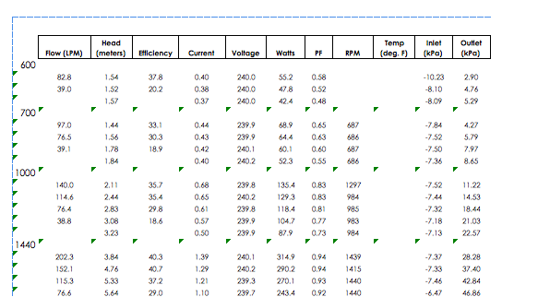

**Fig 6** Squat tank tests of Stelth show negative pressure at the pump inlet…reality

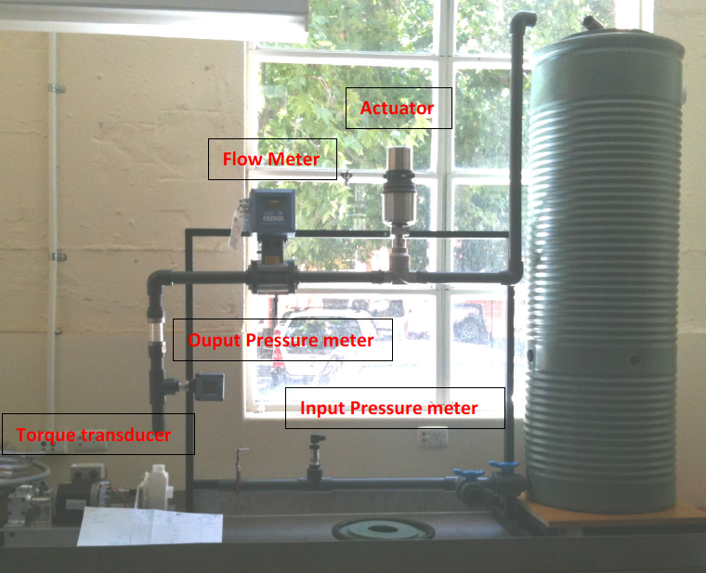

**Fig 7** University of Adelaide tall test stand. Uses tubes from delivery to discharge side to cancel water height pressure, legitimate but not allowed in AS5102.Tall tanks are still ok.

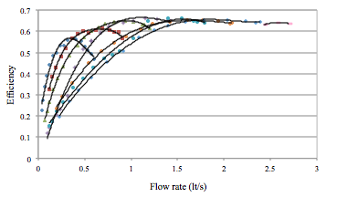

**Fig 8** Early small Stelth pump results from University of Adelaide test stand of **Fig 7**. Power in is shaft watts via torque transducer. This test stand was built at the University specifically for Stelth pump testing

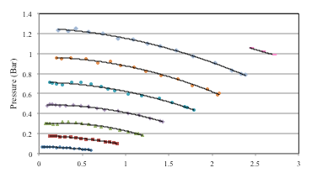

**Fig 9** Pressure curves of **Fig 8.** Stelth pump is 130 mm OD and run at 8 different RPM’s

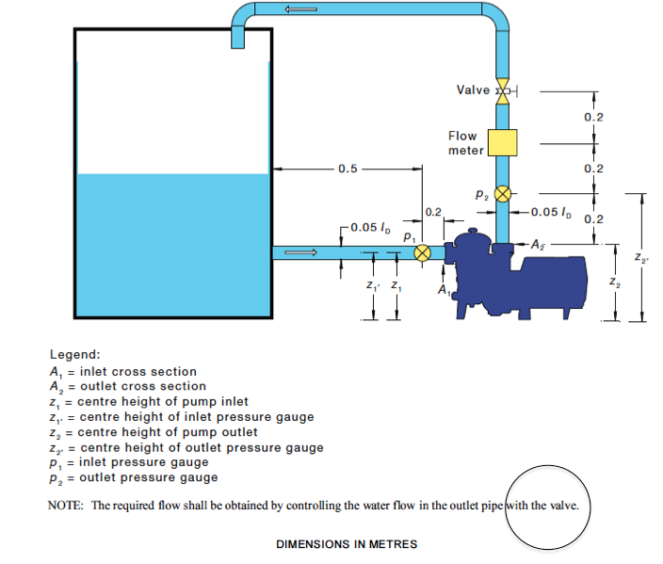

**Fig 10** AS5102 compliant water level gives about 6kPa positive pressure to inlet

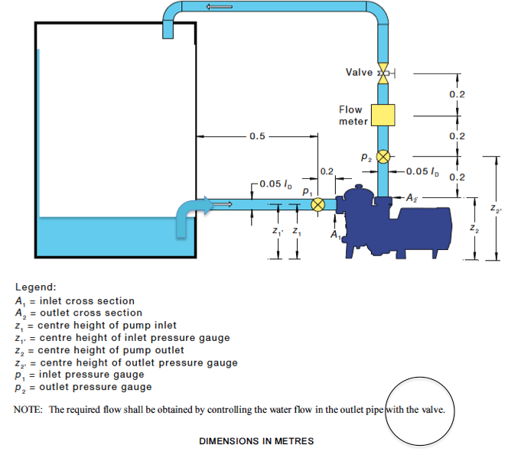

**Fig 11** AS5102 - compliant or non-compliant? Water level gives about negative 2kPa pressure at inlet

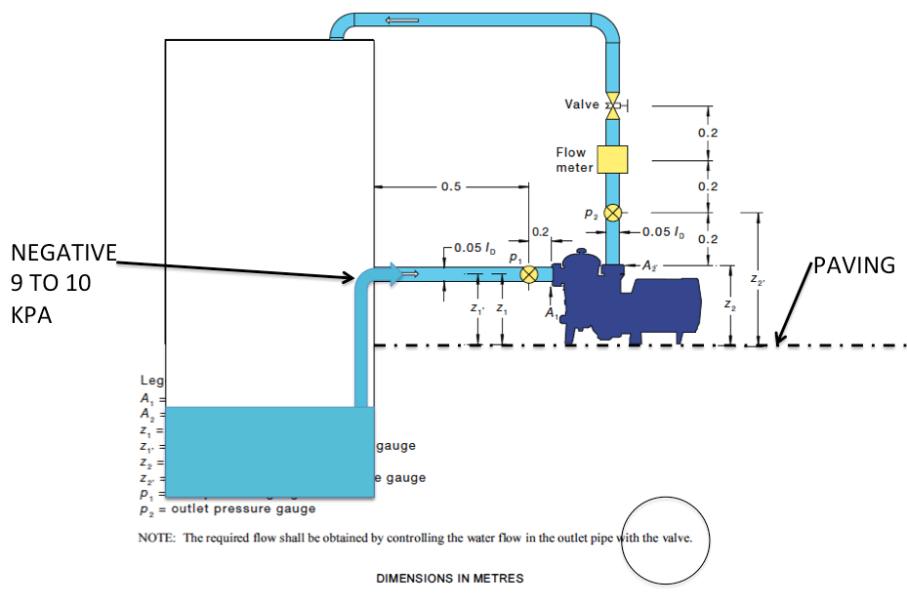

**Fig 12** AS5102 non-compliant water level? But this is reality and causes 9 to 10 kPa negative pressure at inlet

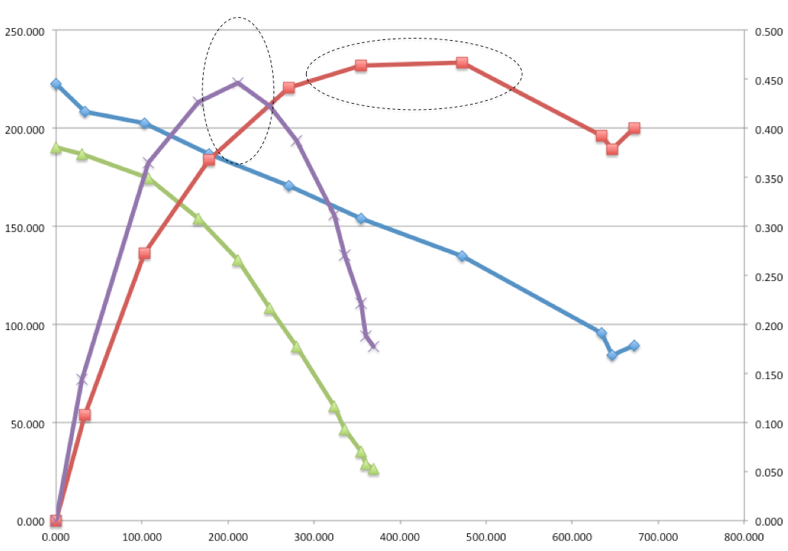

EFFICIENCY CURVES

**Fig 13** Zodiac and Stelth pressure and efficiency curves. Zodiac motor = Fasco iMPower 1hp 2850 RPM. Stelth motor = Zodiac E Pump motor 2830 RPM. BEP’s are outlined for each. Large pressure/flow range of large pool pumps between the dotted lines.

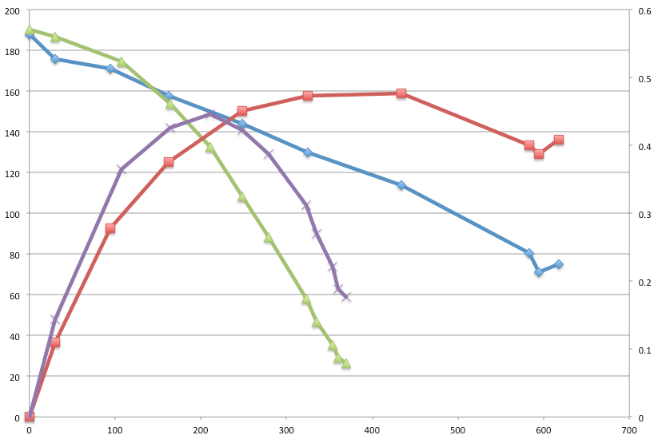

**FIG 14** Stelth at 2600 RPM. Zodiac curves are same as in **Fig 13**

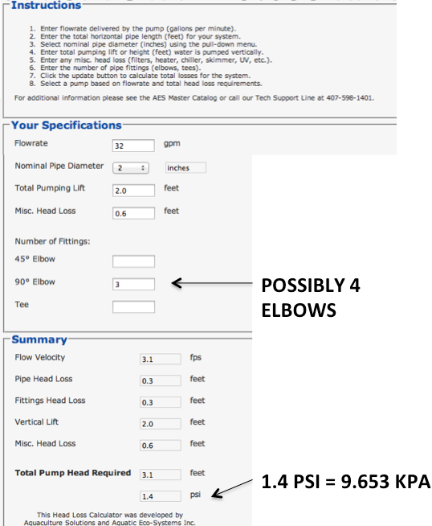

**Fig 15** This head calculator is downloadable from the Internet. Average pump height above the water gives 9 to 10 kPa negative pressure at the pump inlet. Just enter height above the water, distance from the water and number of elbows. 4 elbows are common

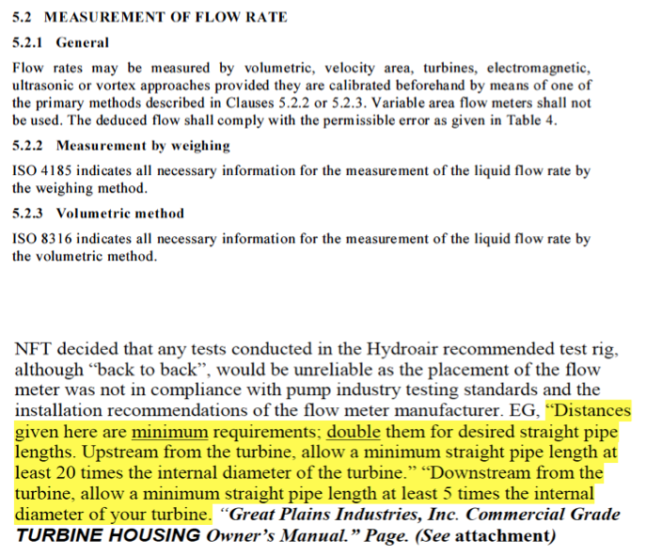

**Fig 16** Turbines, allowable in AS5102, are impractical due to manufacturers recommendations unless employed with a squat, wide tank (see **Fig 17** and **Fig 18**)

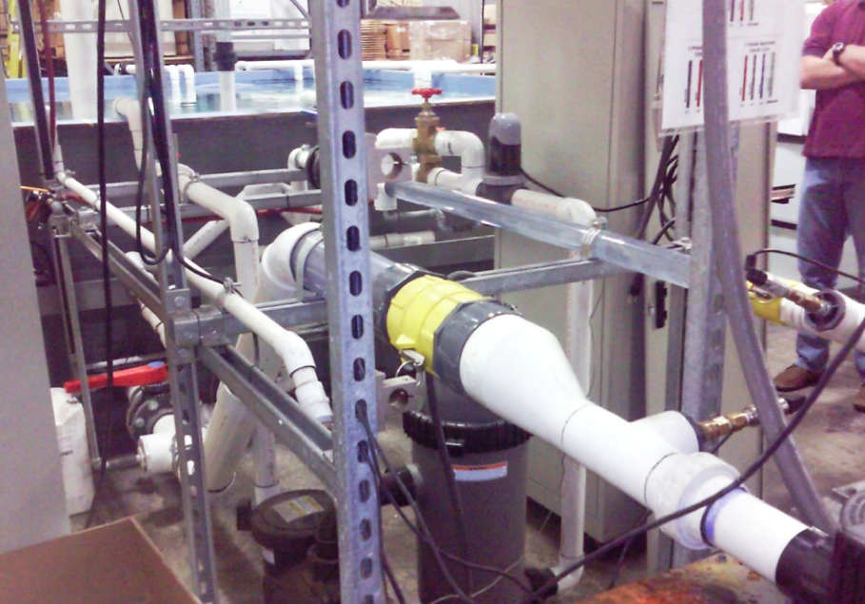

**Fig 17** Conventional squat test stand tank

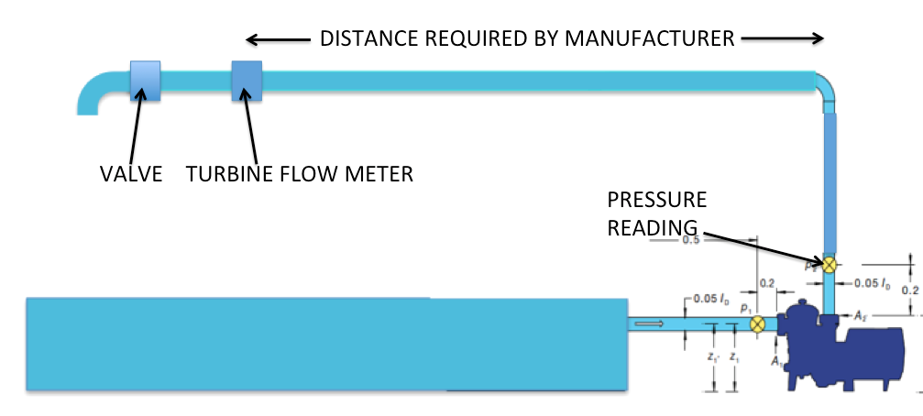

**Fig 18** layout necessary if turbine flow meters are employed allowable in AS5102.